125. Spring MVC Form Tags Overview

1. **Spring MVC Form Tag**: Configurable and reusable for a web page. Advantage: Data Binding (Automatically setters/getters are called)
2. 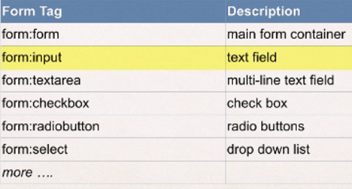
3. **Web Page Structure**: JSP page with special Spring MVC Form tags.  
   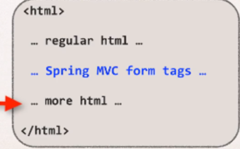
4. How to reference Spring MVC Form Tags



126. Text Fields – Overview

1. Spring MVC Form Tag – Text Field
2. Before showing the form, you must add a **model Attribute**. This is the bean that will hold form data for the **data binding**.
3. 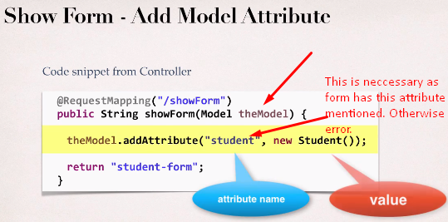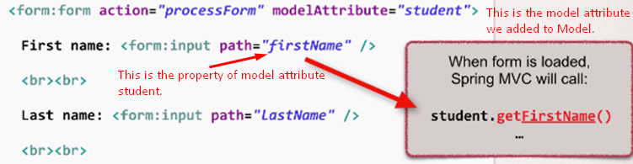

130. Drop-Down Lists – Overview

1. <form:select>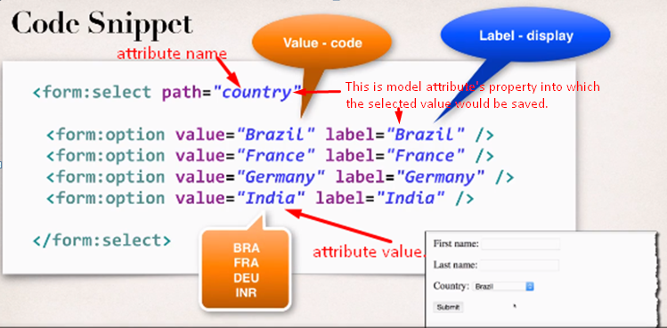

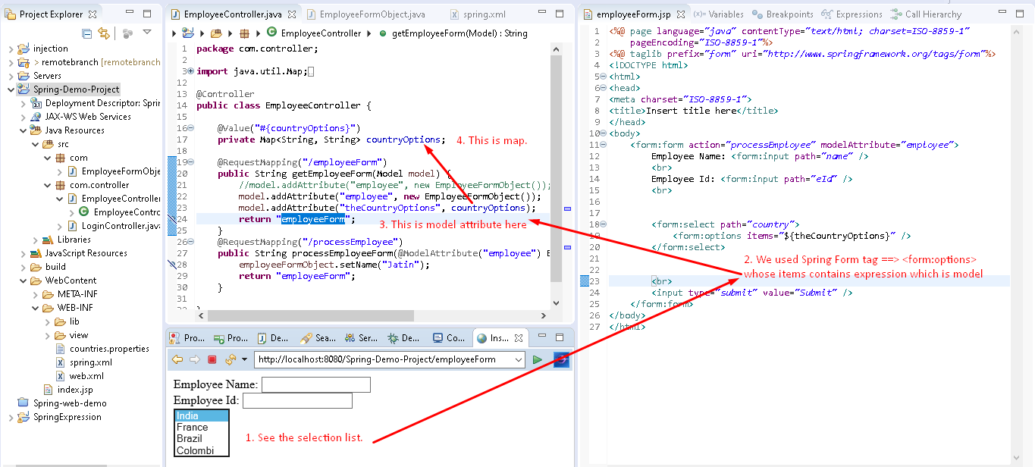

133-faq-use-properties-file-to-load-country-options



134. Radio Buttons – Overview

1. Spring MVC Form Tag – Radio Buttons
2. Spring MVC Tag: 
3. 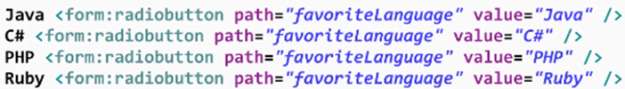



137. Checkboxes – Overview

1. The Spring Tag: <form:checkbox>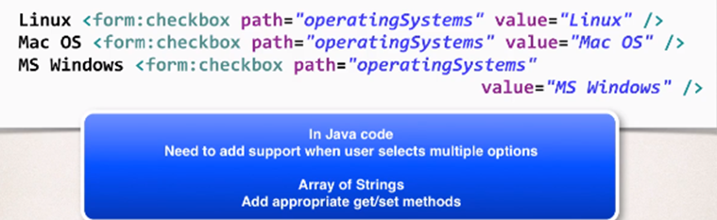

138. Checkboxes - Write Some Code - Part 1

1. 